1. **Understand the Problem**

You are trying to classify images of faces into expressions like:  
😄 Happy, 😢 Sad, 😠 Angry, 😲 Surprise, 😐 Neutral, etc.

1. **Collect or Use Existing Dataset**

Popular Datasets:

Dataset should have:

Face images (grayscale or color)

Labels (happy, sad, angry, etc.)

**3 Preprocess the Data**

**Resize** all images to the same size (e.g., **48x48** pixels).

Convert to grayscale if needed.

**Normalize** pixel values to range [0, 1] (rescale=1./255).

**Augment** images (optional but helpful):

* Rotation, zoom, shift to make model robust.

1. **Build the Model**

For this we are making custom cnn model for learning purposes.

What it means: You build a Convolutional Neural Network (CNN) from scratch.

You design:

* How many layers there are (convolutional layers, pooling layers, dense layers, etc.)
* Number of filters, filter sizes, activation functions, etc.

4. **Train the Model**

Use your train_generator and validation_generator.

Set:

* Optimizer (e.g., Adam)
* Loss function (categorical_crossentropy)
* Metrics (accuracy)

1. **Train the Model**

Use your train_generator and validation_generator.

Set:

* Optimizer (e.g., Adam)
* Loss function (categorical_crossentropy)
* Metrics (accuracy)

Train for ~30–50 epochs (monitor for overfitting).

1. **Evaluate the Model**

Check:

* Accuracy on validation/test set
* Confusion Matrix (to see where the model is confused)

Use EarlyStopping and ModelCheckpoint callbacks during training.

6.Deploy

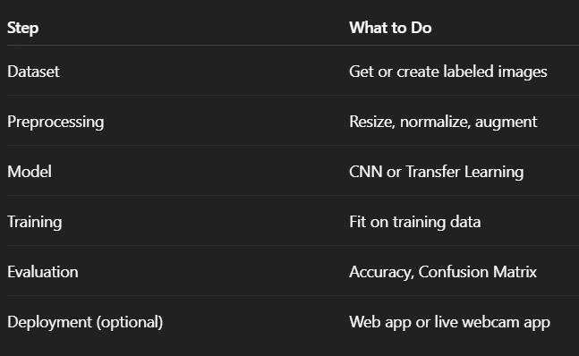Train for ~30–50 epochs (monitor for overfitting).